**Wednesday** (Sara Lee)

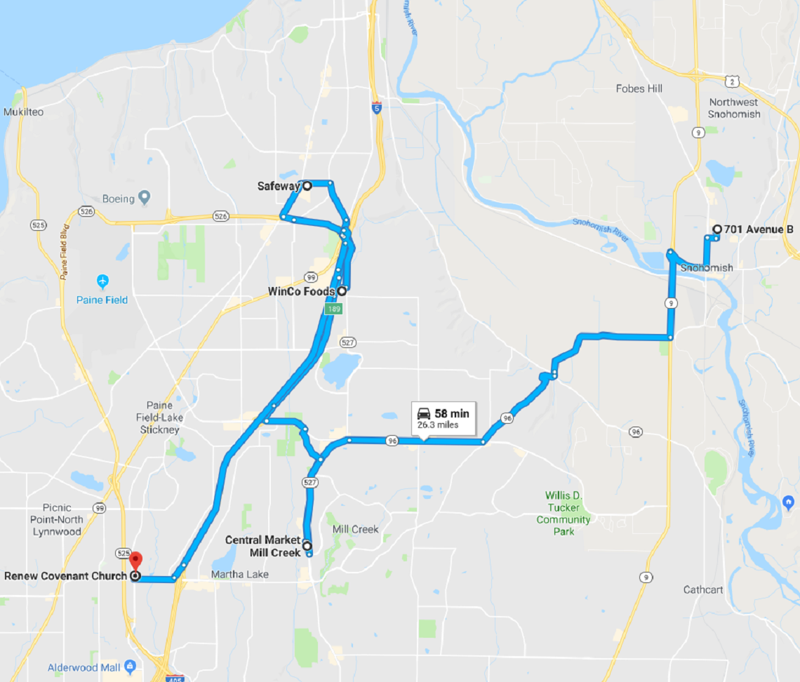

Notes: